What’s On
COVID-19: Please keep your face covering on and stay in your seat until instructed by the stewards. Sadly we are not permitted to sing – please reflect on the words on the screen as the music plays. Please take this handout home with you as you leave.

Next Sunday 8th August, 10 am
Philippians 2:12-30 – All In: Strategic Thinking

Sunday 1st August

Philippians 2:1-11
All In: Gospel Thinking
Leader: Simon Tomlinson
Preacher: Elias Ghazal
Summer Book Group: Whilst taking a break from our normal groups over the summer we are holding some Summer Book Groups. We will be reading Being the Bad Guys by Stephen McAlpine together. Please contact info@moorlands.org.uk if you would like to join a group or to order a copy of the book from our resources desk for £6.

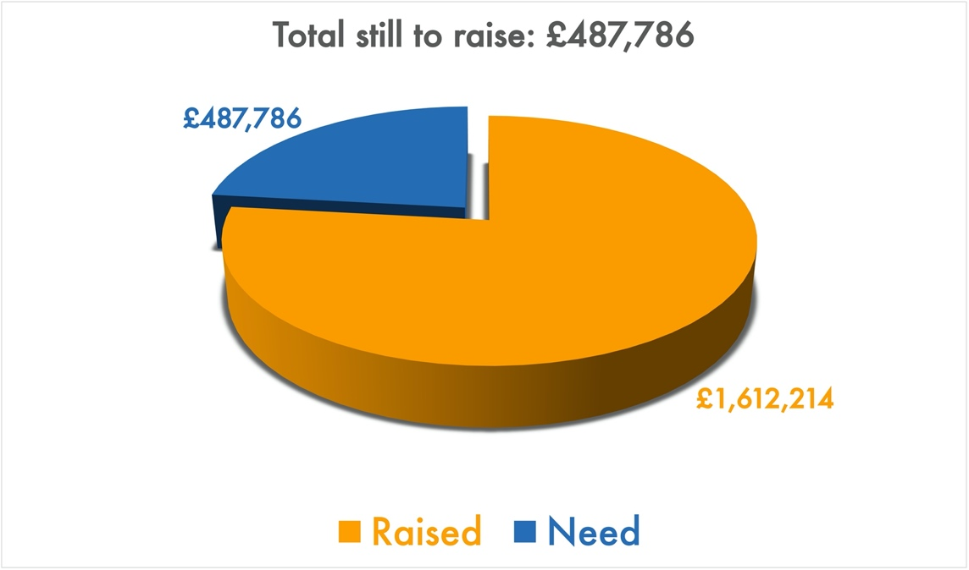
Building for Growth Update
Position at 14 July 2021

Welcome to our Sunday meeting!

We’re really glad you are able to join us today.

Our website, www.moorlands.org.uk, has plenty of information about who we are, what we believe, and what’s on for you.

The back page of this handout also shows what’s coming up in the life of our church.

How to give
For more information regarding our Building for Growth Project and for details on how to give please visit www.moorlands.org.uk/bfg
Get in touch
If you have any questions, or want any more information, please do contact us at info@moorlands.org.uk, or through the website.

Philippians 2:1-11

Introduction

- Be of one mind (1-4)

- Gospel unity (1-2)

- Threat to unity (2-4)

- Mind of Christ (5-11)

Conclusion

For reflection: Consider what stands in the way of you putting on the mind of Christ, and reflect on how the example of Jesus can help you overcome that.

