What’s On
COVID-19: Please keep your face covering on and stay in your seat until instructed by the stewards. Sadly we are not permitted to sing – please reflect on the words on the screen as the music plays. Please take this handout home with you as you leave.
Next Sunday 10th October, 10am
2 Samuel 11:1-5 – The Schemes of Man & The Scandal of Grace: The Disaster

Prayer Tea, Today, 4pm-6pm, High Street: This afternoon is our monthly Prayer Tea, where we’ll be praying for our church, our city, and our world together. We will also be welcoming some New Partners. Please do join us if you can.

Sunday 3rd October

Matthew 12:15-21
Take Another Look:
He fixes the world
Leader: Jack Graham
Preacher: Nathan Weston

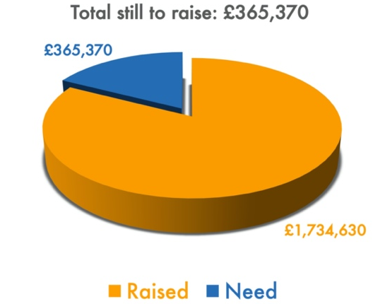
STUDENTS
Welcome if you’re new to Lancaster and welcome back to returning students. We’re excited to have you back in Lancaster. Please do pick up a Student Welcome Pack after church if you’re new!
In particular take note of:
Student Lunches: Happening in homes today and every Sunday in October.
Student Real Food: Starts next Sunday (10 October) 6pm at the High Street. This is our Sunday evening programme for students, which includes a meal, a talk, and small group Bible studies. We’d love you to join even if you wouldn’t yet consider Moorlands to be your church family.
For more information please speak to Joe Standerwick or see www.moorlands.org.uk/students

Building for Growth Update

Position at End of September
Welcome to our Sunday meeting!

We’re really glad you are able to join us today.
We welcome children to our Sunday meetings. The children leave part way through for their own Bible teaching time. There are three groups: Baby Grubs (ages 0-2), Mini Grubs (ages 3-4); and Grub Groups (Reception to Year 6). There is also a video link room available for those who would find it useful.

The back page of this handout shows what’s coming up in the life of our church.

Our website, www.moorlands.org.uk, has plenty of information about who we are, what we believe, and what’s on for you.

Matthew 12:15-21

Introduction

1. Jesus’ justice is true

2. Jesus’ justice is patient

3. Jesus’ justice is merciful

Conclusion

OVER COFFEE: Which is the more offensive to our world – the claim that Jesus will bring justice, or the claim that those who trust in Jesus will be shown mercy? Why?

