What’s On
COVID-19: Please keep your face covering on and stay in your seat until instructed by the stewards. Sadly we are not permitted to sing – please reflect on the words on the screen as the music plays. Please take this handout home with you as you leave.

Next Sunday 12th September, 10 am
Matthew 11:1-19 – Take Another Look: He mends the broken

Sunday 5th September

Philippians 4:10-23
All In: Contentment in the Gospel
Leader: Danny Rurlander
Preacher: Nathan Weston

Children’s groups
We welcome children to our Sunday meetings. The children leave part way through for their own Bible teaching time.
There are three groups:
- Baby Grubs (ages 0-2) in the meeting room
- Mini Grubs (ages 3-4) in the training room
- Grub Groups (Reception to Year 6) in the hall upstairs

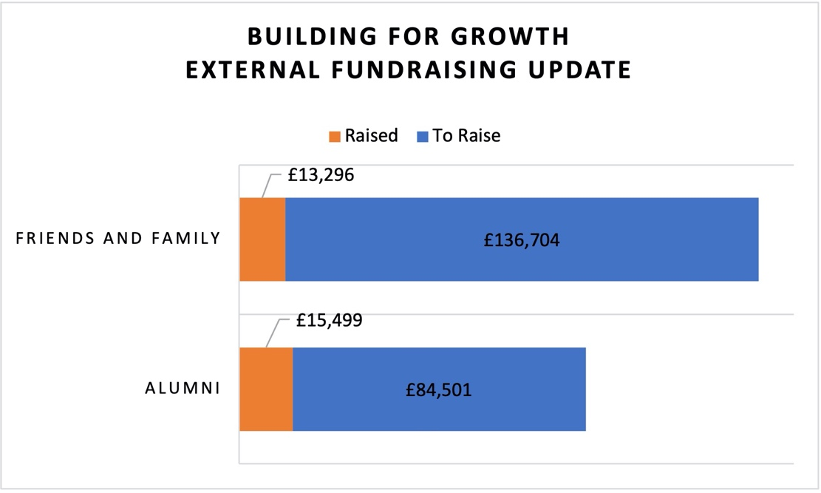
There is also a video link room available for those who would find it useful. Speak to a member of the Welcome Team for more information.
Position at the End of August
Get in touch
If you have any questions, or want any more information, please do contact us at info@moorlands.org.uk, or through the website.

Welcome to our Sunday meeting!

We’re really glad you are able to join us today.

Our website, www.moorlands.org.uk, has plenty of information about who we are, what we believe, and what’s on for you.

The back page of this handout also shows what’s coming up in the life of our church.

Get in touch
If you have any questions, or want any more information, please do contact us at info@moorlands.org.uk, or through the website.

Philippians 4:10-23

Introduction

- Being all-in for Jesus brings contentment – because God strengthens us: 10-13

- Being all-in for Jesus bring joy – because God out-gives us: 14-17

- Being all-in for Jesus leads to glory – because God is for us: 18-20

Conclusion: 21-23

FOR DISCUSSION: When are we tempted to think that being all-in for Jesus is not worth it? What do we fear we’re missing out on?

