What’s On
COVID-19: Please keep your face covering on and stay in your seat until instructed by the stewards. Sadly we are not permitted to sing – please reflect on the words on the screen as the music plays. Please take this handout home with you as you leave.
Next Sunday 14th November, 10am
2 Samuel 13:1-22 – The Schemes of Man & The Scandal of Grace: Like Father, Like Son

Sunday 7th November

2 Samuel 12:15-31
The Schemes of Man & The Scandal of Grace
The Scandal of Grace
Leader: Nathan Weston
Preacher: Danny Rurlander

Prayer Tea, This afternoon, 4pm-6pm:
This afternoon is our monthly Prayer Tea. We’ll be praying for our church, our city, and our world together. We will also be welcoming some New Partners. Please do join us if you can.

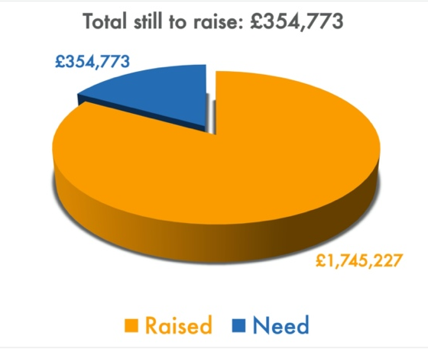
Get in touch
If you have any questions, or want any more information, please fill in a contact form on your pew, speak to one of the Welcome Team or email us at info@moorlands.org.uk.

Building for Growth Update

Position at End of October
Welcome to our Sunday meeting!

We’re really glad you are able to join us today.
We welcome children to our Sunday meetings. The children leave part way through for their own Bible teaching time. There are three groups: Baby Grubs (ages 0-2), Mini Grubs (ages 3-4); and Grub Groups (Reception to Year 6). There is also a video link room available for those who would find it useful.

The back page of this handout shows what’s coming up in the life of our church.

Our website, www.moorlands.org.uk, has plenty of information about who we are, what we believe, and what’s on for you.

2 Samuel 12:15-31

Introduction

1. Re-learning God’s place: 15-23

2. Receiving God’s grace: 24-31

References: 1 Timothy 3:4-5; Matthew 18:21-35; Matthew 6:12; Colossians 3:13; 2 Samuel 7:13-16

Reflection: Colossians 1:13-14 For he has rescued us from the dominion of darkness and brought us into the kingdom of the Son he loves, in whom we have redemption, the forgiveness of sins.

