What’s On
COVID-19: Please keep your face covering on and stay in your seat until instructed by the stewards. Sadly we are not permitted to sing – please reflect on the words on the screen as the music plays. Please take this handout home with you as you leave.

Next Sunday 19th September, 10 am
Matthew 11:20-30 – Take Another Look: He offers rest to the weary

Sunday 12th September

Matthew 11:1-19
Take Another Look: He mends the broken
Leader: Nathan Weston
Preacher: Joe Standerwick

Children’s groups
We welcome children to our Sunday meetings. The children leave part way through for their own Bible teaching time.
There are three groups:
- Baby Grubs (ages 0-2) in the meeting room
- Mini Grubs (ages 3-4) in the training room
- Grub Groups (Reception to Year 6) in the hall upstairs

There is also a video link room available for those who would find it useful. Speak to a member of the Welcome Team for more information.
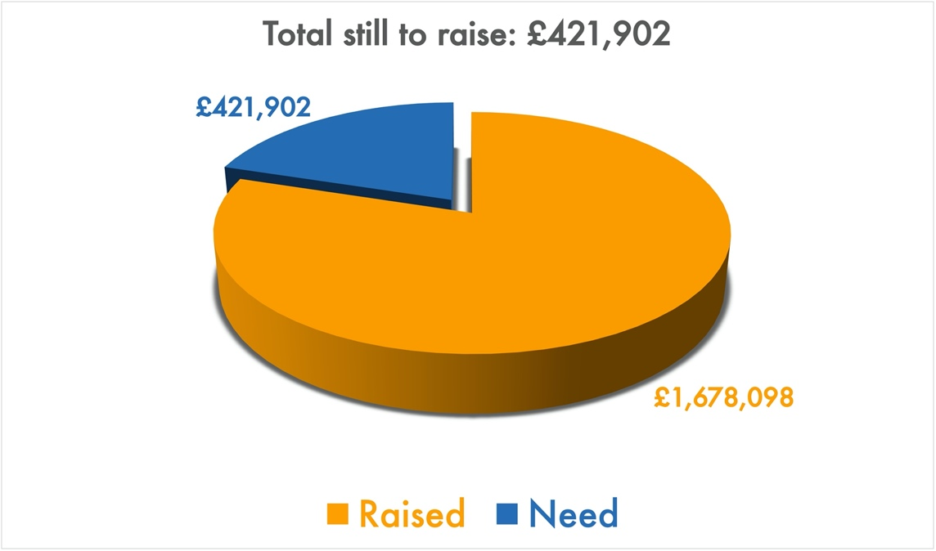
Building for Growth Fundraising Update
Get in touch
If you have any questions, or want any more information, please do contact us at info@moorlands.org.uk, or through the website.

Welcome to our Sunday meeting!

We’re really glad you are able to join us today.

Our website, www.moorlands.org.uk, has plenty of information about who we are, what we believe, and what’s on for you.

The back page of this handout also shows what’s coming up in the life of our church.
Position at the End of August

Matthew 11:1-19

Introduction

- The arrival of the kingdom of heaven (1-6)

- The advancement of the kingdom of heaven (7-15)

- Our attitude to the kingdom of heaven (16-19)

Conclusion

ISAIAH PASSAGES FOR REFLECTION: Isaiah 26:19; 29:18-19; 35:1-10; 61:1-3

