What’s On
COVID-19: Please keep your face covering on and stay in your seat until instructed by the stewards. Sadly we are not permitted to sing – please reflect on the words on the screen as the music plays. Please take this handout home with you as you leave.

Next Sunday 22nd August, 10 am
Philippians 3:12 – 4:1 – All In: Forward Thinking

Sunday 15th August

Philippians 3:1-11
All In: Confident Thinking
Leader: Dan Jenkinson
Preacher: Neil Richmond

Children’s groups
Over the month of August we are providing a video link in the hall, with toys and colouring sheets, for parents to take their pre-school children to during the sermon. We will resume groups for primary-aged children in September. For more details please talk to a member of the welcome team.

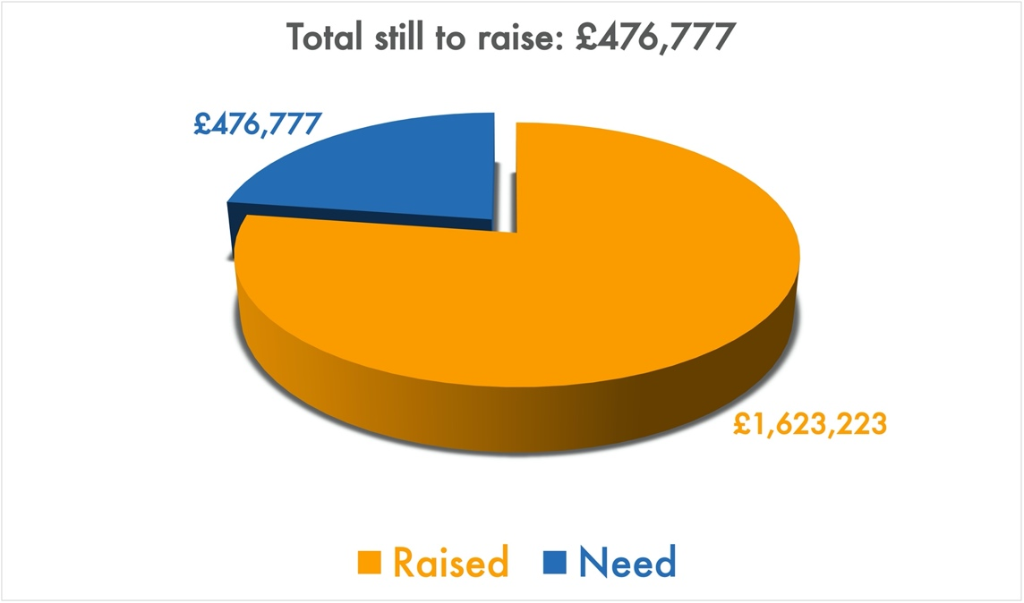
Building for Growth Update
Position at end of July 2021

Welcome to our Sunday meeting!

We’re really glad you are able to join us today.

Our website, www.moorlands.org.uk, has plenty of information about who we are, what we believe, and what’s on for you.

The back page of this handout also shows what’s coming up in the life of our church.
Get in touch
If you have any questions, or want any more information, please do contact us at info@moorlands.org.uk, or through the website.

Philippians 3:1-11

Introduction

- The Danger of Wrong Confidence (1-7)

- The Safety of Right Confidence (8-11)

1. The incomparable worth of knowing Jesus

2. Confidence in the Resurrection

Conclusion

FOR REFLECTION: In what ways are you holding back from following Jesus? How does understanding the incomparable worth of knowing him change that?

