What’s On
COVID-19: Please keep your face covering on and stay in your seat until instructed by the stewards. Sadly we are not permitted to sing – please reflect on the words on the screen as the music plays. Please take this handout home with you as you leave.

Next Sunday 1 August, 10 am
Philippians 2:1-11 – All In: Gospel Thinking
Summer Book Group: Whilst taking a break from our normal groups over the summer we are holding some Summer Book Groups. We will be reading Being the Bad Guys by Stephen McAlpine together. Please contact info@moorlands.org.uk if you would like to join a group or to order a copy of the book from our resources desk for £6.

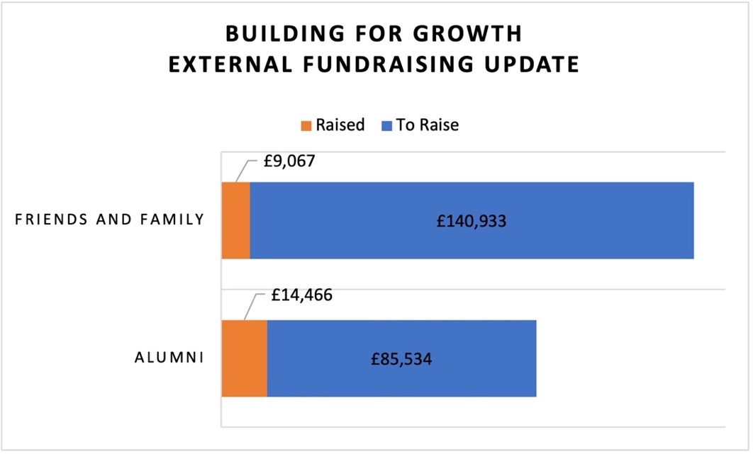
Welcome to our Sunday meeting!

We’re really glad you are able to join us today.

Our website, www.moorlands.org.uk, has plenty of information about who we are, what we believe, and what’s on for you.

The back page of this handout also shows what’s coming up in the
life of our church.

How to give
For more information regarding our Building for Growth Project and for details on how to give please visit www.moorlands.org.uk/bfg
Position at 14 July 2021
How to give
For more information regarding our Building for Growth Project and for details on how to give please visit www.moorlands.org.uk/bfg

Get in touch
If you have any questions, or want any more information about our church please do visit our website or contact us at info@moorlands.org.uk.

Sunday 25th July

Philippians 1:12-30
All In: Advancing the Gospel
Leader: Danny Rurlander
Preacher: Andrew Blain

Philippians 1:12-30

Introduction

1. Rejoice in gospel progress

- Outsiders

- Brothers

c. Rivals

2. Live for gospel priorities

3. Strive with gospel partners

Conclusion

