What’s On
COVID-19: Please keep your face covering on and stay in your seat until instructed by the stewards. Sadly we are not permitted to sing – please reflect on the words on the screen as the music plays. Please take this handout home with you as you leave.

Next Sunday 5th September, 10 am
Philippians 4:10-23 – All In: Contentment in the Gospel

Sunday 29th August

Philippians 4:2 – 9
All In: Contending for the Gospel
Leader: Andrew Blain
Preacher: Joe Standerwick

Children’s groups
Over the month of August we are providing a video link in the hall, with toys and colouring sheets, for parents to take their pre-school children to during the sermon. We will resume groups for primary-aged children in September. For more details please talk to a member of the welcome team.

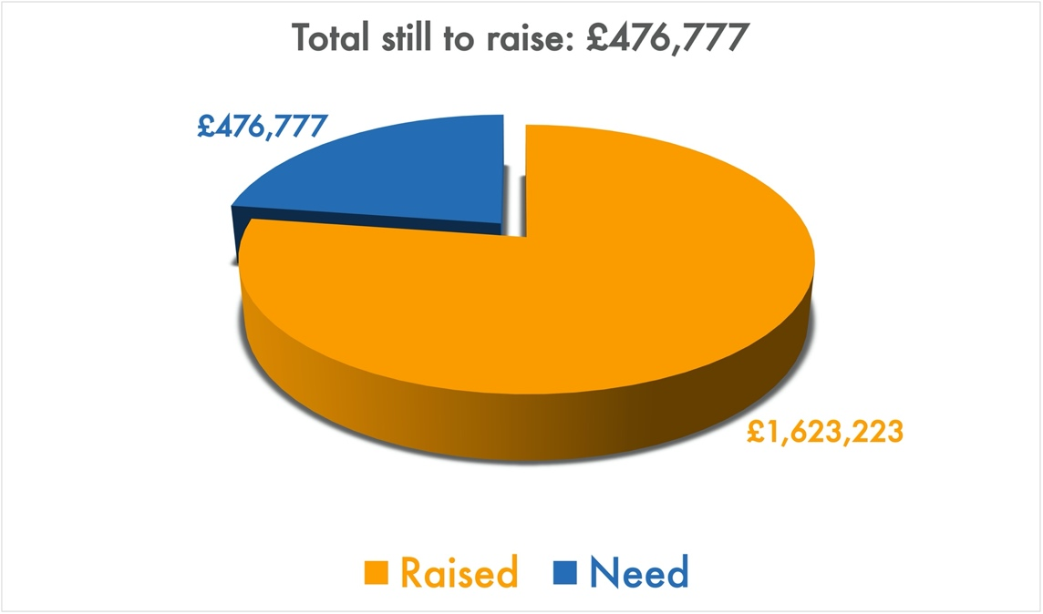
Building for Growth Update
Position at end of July 2021

Get in touch
If you have any questions, or want any more information, please do contact us at info@moorlands.org.uk, or through the website.

Welcome to our Sunday meeting!

We’re really glad you are able to join us today.

Our website, www.moorlands.org.uk, has plenty of information about who we are, what we believe, and what’s on for you.

The back page of this handout also shows what’s coming up in the life of our church.
Philippians 4:2-9

Introduction

- In times of conflict, unite in the Lord (2-3)

- In times of anxiety, trust in the Lord (4-7)

- At all times, live for the Lord (8-9)

Conclusion

FOR REFLECTION: How has this passage challenged you to live a life worthy of the gospel of Christ?

