**The Greatest Mission on Earth**

Talk 5: God’s Mission and the Church

**Introduction**

*Discussion: do you normally think of evangelism as a solo sport of a team sport? Is it more like fishing or football?*

1. **Local churches are the fruit of the gospel**

Ephesians 2

1. **Local churches proclaim the gospel**

*Why is church a good place for friends to hear the gospel?*

i.

Luke 24:44 He said to them, “This is what I told you while I was still with you: Everything must be fulfilled that is written about me in the Law of Moses, the Prophets and the Psalms.” 45 Then he opened their minds so they could understand the Scriptures. (NIV)

ii.

Romans 10:17 Consequently, faith comes from hearing the message, and the message is heard through the word about Christ. (NIV)

iii.

1 Corinthians 14:24 But if an unbeliever or an inquirer comes in while everyone is prophesying, they are convicted of sin and are brought under judgment by all, 25 as the secrets of their hearts are laid bare. So they will fall down and worship God, exclaiming, “God is really among you!” (NIV)

1. **Local churches display the gospel**

“The church isn’t just meant to be a *new* community…it’s meant to be a new *kind* of community.” You’re Not Crazy, Sam Allberry and Ray Ortlund, p25

*A local church displays the gospel as we love one another*

John 13:34-35

*Discussion: what is new about the command Jesus gives?*

*A local church displays the gospel through all the other one anothers*

**Implications**

1. Think corporately when you think about mission

**Committed**

**Disengaged**

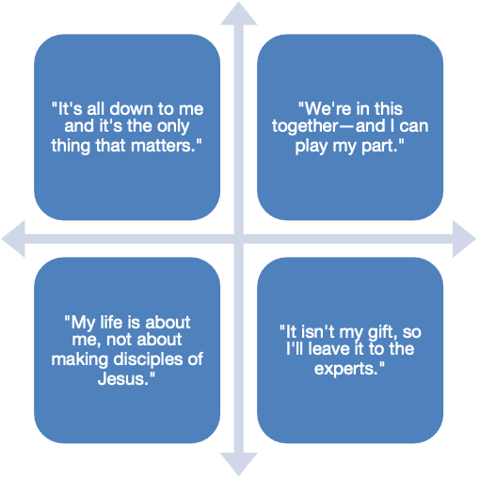

**Corporate**

**Individual**

1. Invite your friends to church
2. Introduce your non-Christian friends to your Christian friends