What’s On
COVID-19: Please keep your face covering on and stay in your seat until instructed by the stewards. Sadly we are not permitted to sing – please reflect on the words on the screen as the music plays. Please take this handout home with you as you leave.

Next Sunday 23rd May – Guest Service
Acts 10:39-43 – Mission Possible: Salvation
Sunday 16th May

Acts 8:26-40
Mission Possible: Evangelism

Leader: Danny Rurlander
Preacher: Joe Standerwick

Join us next week online or onsite at 10am. This would be a particularly good week to invite friends to hear the good news of Jesus with us!
Building for Growth Pledge Day

Building for Growth Fund Update

This Sunday is our Building for Growth pledge day. This is an opportunity for members of our church family to give a financial gift to our building project and there will be a collection during the meeting. If you are a guest today, and you want to know more about the project, go to www.moorlands.org.uk/bfg.

Position at the end of April 2021

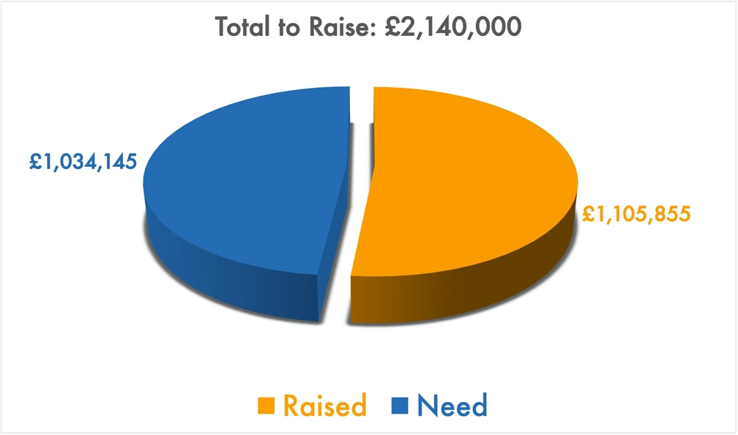

Welcome to our Sunday meeting!

We’re really glad you are able to join us today.

Our website, www.moorlands.org.uk, has plenty of information about who we are, what we believe, and what’s on for you.

The back page of this handout also shows what’s coming up in the life of our church.

COVID-19: Please keep your face covering on and stay in your seat until instructed by the stewards. Sadly we are not permitted to sing – please reflect on the words on the screen as the music plays. Please take this handout home with you as you leave.

Get in touch
If you have any questions, or want any more information, please do contact us at info@moorlands.org.uk, or through the website.

Mission Possible: Evangelism: Acts 8:26-40

Introduction

1. A man from the ends of the earth: 26-28

2. A message for the ends of the earth: 29-39

Confusion

Clarity

Conversion

3. Our mission to the ends of the earth: 40

For reflection: “After this I looked, and there before me was a great multitude that no one could count, from every nation, tribe, people and language, standing before the throne and before the Lamb.” (Revelation 7:9, NIV 2011)

