What’s On
COVID-19: Please keep your face covering on and stay in your seat until instructed by the stewards. Sadly we are not permitted to sing – please reflect on the words on the screen as the music plays. Please take this handout home with you as you leave.

Next Sunday 24th January, 10am
Love in the Time of Covid Part 2

Join us next week online!
www.moorlands.org.uk/sunday.
Sunday 17th January

Luke 6:27-36
Love in the time of Covid

Leader: Nathan Weston
Preacher: Danny Rurlander

Life Course
For anyone looking into Christian belief for the first time. This course runs for five evenings over five weeks, and answers some of the big questions of life. A short talk from the Bible, with a chance to discuss and ask any questions you have.
Thursday 21st January, 8pm, On Zoom.
www.moorlands.org.uk/life
info@moorlands.org.uk

Update from the Finance and Building Teams
Welcome to our Sunday meeting!

We’re really glad you are able to join us today.

Our website, www.moorlands.org.uk, has plenty of information about who we are, what we believe, and what’s on for you.

The back page of this handout also shows what’s coming up in the life of our church.
Moorlands Church is financed mainly by the regular, sacrificial giving of our members.
88%
of current church partners have given to the Building for Growth project
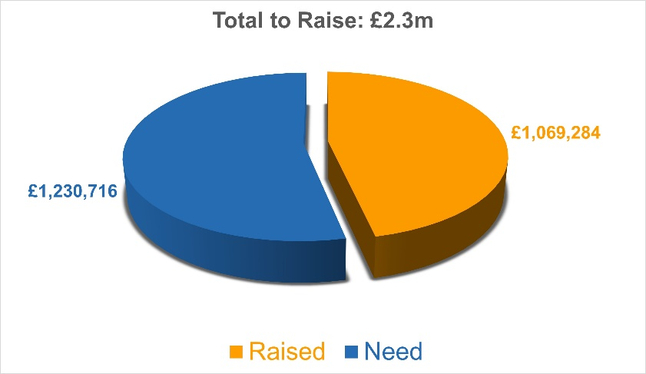
Building for Growth Project Update

144,000
is the number of people in the Lancaster area. We’d love to welcome many to our building to hear about Jesus.

How to Give
For details on how to give please contact finance@moorlands.org.uk

Love in a time of Covid: Luke 6:27-36

Introduction

1. Hard love: 27-31

…your Enemies

Love…

2. Easy love: 32 - 34

3. True love: 35-36

For reflection: Rom. 5:6 You see, at just the right time, when we were still powerless, Christ died for the ungodly. 7 Very rarely will anyone die for a righteous man, though for a good man someone might possibly dare to die. 8 But God demonstrates his own love for us in this: While we were still sinners, Christ died for us.

Prayer: Heavenly Father, I know that I have lived as your enemy and do not deserve to be called one of your children. Thank you for showing your love by sending your Son Jesus to die to take away my sins and bring forgiveness. Please forgive me and change me that I may live with Jesus as my ruler from now on. Amen.

