What’s On
COVID-19: Please keep your face covering on and stay in your seat until instructed by the stewards. Sadly we are not permitted to sing – please reflect on the words on the screen as the music plays. Please take this handout home with you as you leave.

Next Sunday 6th June
2 Samuel 7:1-17 – Long Live the King: A Word from a Prophet

Sunday 30th May

Acts 11:9-30
Mission Possible: Multiplication

Leader: Joe Standerwick
Preacher: Nathan Weston

Join us next week online or onsite at 10am.

Prayer Tea, Next Sunday, 4pm: Next Sunday is our monthly Prayer Tea, where we’ll be praying for our church, our city, and our world together. This will be from 4-5:30pm on Zoom. Church regulars should receive a link by email – if you’d like to join us, please email Becca (becca.holden@moorlands.org.uk).

Building for Growth Update

Building Fund Update
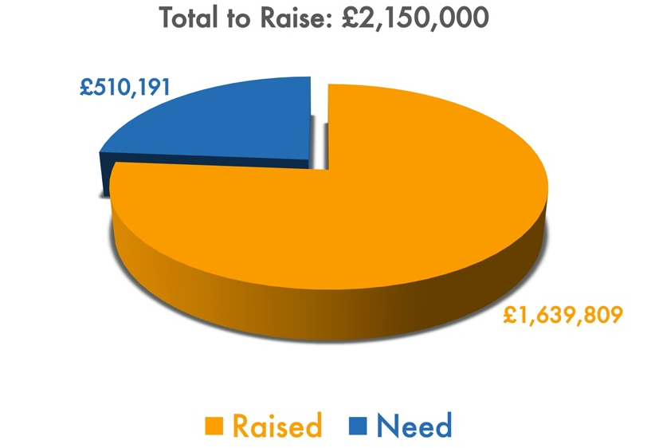
Position as at end of May 2021

Welcome to our Sunday meeting!

We’re really glad you are able to join us today.

Our website, www.moorlands.org.uk, has plenty of information about who we are, what we believe, and what’s on for you.

The back page of this handout also shows what’s coming up in the life of our church.

COVID-19: Please keep your face covering on and stay in your seat until instructed by the stewards. Sadly we are not permitted to sing – please reflect on the words on the screen as the music plays. Please take this handout home with you as you leave.

Get in touch
If you have any questions, or want any more information, please do contact us at info@moorlands.org.uk, or through the website.

Mission Possible: Multiplication: 11:9-30

Introduction

1. A Christian church, formed by Christ’s gospel: 19-21

2. A Christian church, caught up in Christ’s mission: 22-26

3. A Christian church, partnering with Christ’s churches (27-30)

Generosity

Global-mindedness

Genealogy

Gladness

Conclusion

For discussion: Do you consider being called a Christian a privilege? Has this passage changed your mind?

