The Cross of Christ
Talk 5: Take up your cross
“The fox knows many things, but the hedgehog knows one big thing.” Archilochus.

INTRODUCTION

The dimensions of the cross

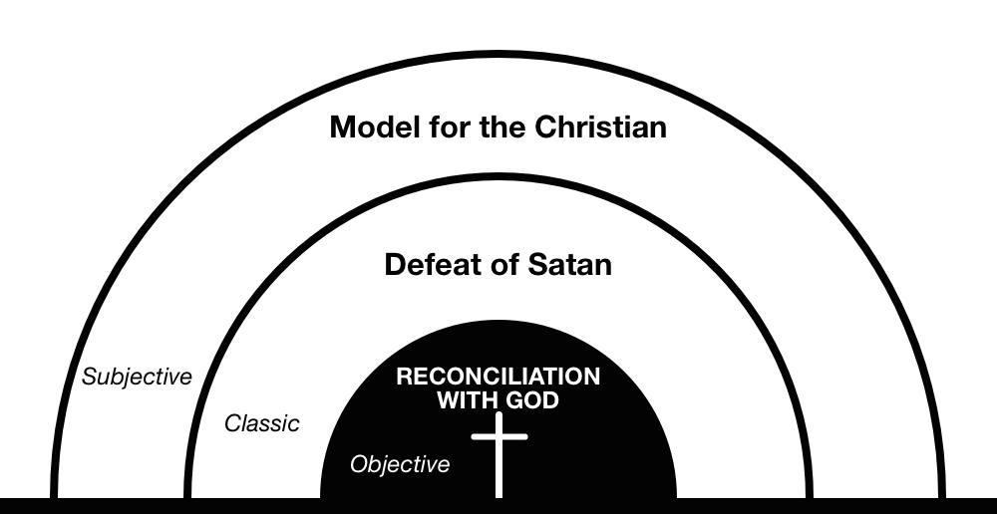

“Objective”

“Classic”

“Subjective”

“So great a pledge of love having been given us, we are both moved and kindled to love God who did such great things for us; and by this we are justified, that is, being loosed from sins we are made just. The death of Christ therefore justifies us, inasmuch as through it charity is stirred up in or hearts.” Peter Lombard

And once again I look upon the cross where you died.
I’m humbled by your mercy and I’m broken inside.
Once again I thank you, once again I pour out my life.
Matt Redman

1 Peter 2:21 To this you were called, because Christ suffered for you, leaving you an example, that you should follow in his steps.

A. TAKE UP YOUR CROSS?

Mark 8:31 - 9:1

Our cross will be the cost to us, as the people we are, in the circumstances God has designed for us, of contributing what we can to making disciples of all nations for him - knowing that Jesus wants to reward us for eternity. Richard Coekin, The Cross in Four Words.

Mark 14:27-31, 66-72; 15:21-22

- Galatians 2:20a I have been crucified with Christ and I no longer live, but Christ lives in me.

- Galatians 6:14 May I never boast except in the cross of our Lord Jesus Christ, through which the world has been crucified to me, and I to the world.

- Romans 6:6-7 For we know that our old self was crucified with him so that the body of sin might be done away with, that we should no longer be slaves to sin— because anyone who has died has been freed from sin.

- Colossians 3:3 For you died, and your life is now hidden with Christ in God.

- 2 Corinthians 5: 14-15 For Christ’s love compels us, because we are convinced that one died for all, and therefore all died. And he died for all, that those who live should no longer live for themselves but for him who died for them and was raised again.

- 2 Timothy 2: 11-12 Here is a trustworthy saying: If we died with him, we will also live with him; if we endure, we will also reign with him.

- Philippians 1:21 For to me, to live is Christ and to die is gain.

B. YOU HAVE DIED WITH CHRIST, THEREFORE LIVE IN CHRIST

1. You have died to self so serve Christ single-mindedly

2 Corinthians 5: 14 For Christ’s love compels us, because we are convinced that one died for all…

2. You have died to sin so embrace your new self

Galatians 5: 24 Those who belong to Christ Jesus have crucified the sinful nature with its passions and desires. 25 Since we live by the Spirit, let us keep in step with the Spirit.

Galatians 5:22 But the fruit of the Spirit is love, joy, peace, patience, kindness, goodness, faithfulness, 23 gentleness and self-control.

3. You have died to shame to speak boldly

“All that Christ had done towards effecting a reconciliation would have been of no service,
if it had not been proclaimed by the gospel.” John Calvin

Revelation 12: 11
They overcame him
by the blood of the Lamb
and by the word of their testimony;
they did not love their lives so much
as to shrink from death.

2 Timothy 2:10 Therefore I endure everything for the sake of the elect, that they too may obtain the salvation that is in Christ Jesus, with eternal glory.

4. You have been crucified with Christ, so sing triumphantly

Revelation 5

Response: write down one idea that you would like to think more about

