Real Food Short Talks: Autumn Term 2023
KNOWING GOD
1. Introduction

INTRODUCTION
“Only one thing is needed”
Luke 10:38-42

Only one thing is central

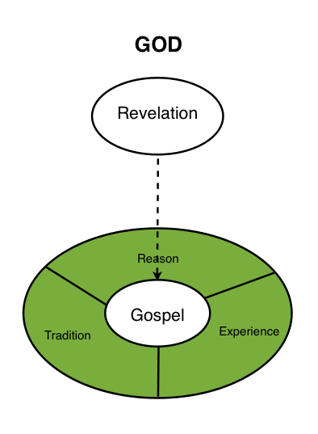
Experience…

Reason…

Tradition…

Revelation

Christianity is_____________________________________________________________________

